PRESS MATERIAL:



**made in copenhagen presents**

**SKÁL**

***A film by Cecilie Debell and Maria Tórgarð***

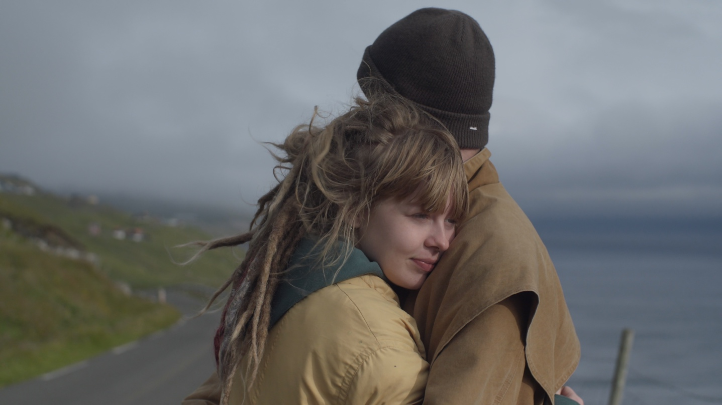

Photo: Troels Rasmus Jensen

**World premiere at CPH:DOX Saturday April 24th at 4.30 pm followed by a Q&A with the characters and the director. The film is in the main competition.**

Links to the film can now be requested.

For interview appointments, please contact Publicist Line Bilenberg: 20710494, [line.bilenberg@gmail.com](mailto:line.bilenberg@gmail.com)

Press material can be downloaded at: [www.madeincopenhagen.dk](http://www.madeincopenhagen.dk/)  - under ’press’

**Trailer: I can send later – not done yet**

Original title: SKÁL/duration: 75 min.

**CONTENT**

Page 2 Introduction

Page 3 Synopsis

Page 3 About the characters

Page 4 Director’s thoughts and motivation by Cecilie Debell

Page 5 Director’s thoughts and motivation by Maria Tórgarð

Page 5 Facts

Page 6 Short biographies

Page 6 About made in copenhagen

Page 7 The film is funded by

**INTRODUCTION**

It’s the first time ever that a documentary film about the Faroe Islands has been selected for an A-list film festival – no less for the main competition. That alone makes **SKÁL** exceptional and noteworthy in the Faroe Islands. The title ”Skál” comes from the collection of poems that the main character of the film, Dania, publishes while the film is being made. The poetry collection sold more than 500 copies and was at the top of the bestseller list in the Faroe Islands the month it was published. It is now being taught in primary schools, high schools, and universities.

But the film starts somewhere else entirely. It’s directed by Danish Cecilie Debell (33) and Faroese debutant Maria Tórgarð (23). The film is a portrait of youth dedicated to Cecilie Debell’s younger ’self’ as well as to Maria Tórgarð and all the other young Faroese, as being *the* film missing from their lives. It’s about figuring out who you are, testing boundaries, and being suppressed by a sense of social control. Themes that most young people can relate to, the feeling of being trapped between what you grew up with and the world that you, as a young person, are now exposed to and which will inform your identity.

Dania comes from a Christian congregation in the Faroe Islands. Her entire family is part of this congregation, and Dania is one of the prominent young people, in part because she sings at the services, concerts, etc. But when Dania falls in love with hip-hop artist, Trygvi (with the artist name Silver Boy), it sparks a teenage rebellion, which she lives out together with her friend Marjun. It’s not because they want to leave the congregation – they just want to be accepted as themselves. But how do you find that balance? And how does the congregation react when Dania publishes a collection of poems reeking of youth, anxiety, and freedom?

A survey by KVF and Lógir from 2017 shows that 81% of Faroese people believe in God or some kind of a higher power[1], as opposed to Denmark, where only 37% responded that they believe in God, based on a survey conducted by YouGov in 2019.[2] Conservative Christian attitudes play a major role in Faroese public and political life, which is also why they don’t have freedom of abortion, for example.

*The film is dedicated to all young people – but in particular, those who grew up with the feeling of being suppressed by social control – both when it happens in religious environments and in general between children and their parents or even young people amongst themselves.* Read more on page 3 in the section called Director’s thoughts and motivation.

**SYNOPSIS**

Skál

*- cheers to feeling dirty each time the sun rises*

A young woman stages a youth rebellion of her own design on the Faroe Islands, where the Christian faith is facing a new era.

Dania is 21 years old and grew up in a Christian community in the Faroe Islands' Bible belt. She has just moved to Tórshavn and is seeing Trygvi, a hip-hop artist and poet locally known as Silvurdrongur (Silver Kid). He comes from a secular family and writes poems and texts about the shadow sides of humanity. Dania herself sings in a Christian band but is fascinated by Trygvi's courage to write brutally honest lyrics. As she tries to find her place in the world and understand herself, she starts to write more personal texts. Her writings develop into a collection of critical poems called 'Skál' ('Cheers'), about the double life that she and other youths must live in the conservative Christian world. A world she does not want to abandon, but to change. Where do you draw your lines when you are young and Christian? Is it a sin to drink or dance? Is it a sin to have sex before marriage? Is it a sin to have a boyfriend who is not a Christian? And how long can you endure living between two worlds?

**ABOUT THE CHARACTERS**

**Dania**

Dania O. Tausen is 22 years old and studies at the Author Academy in Tórshavn.

She grew up in a Christian family with three older siblings, where God was an important presence in their lives. She attended Sunday school and sung and performed for the congregation ever since she was a little girl. Two years ago, she moved to Tórshavn - away from the small village of Toftir, which is located in an area referred to as the Faroe Islands' Bible belt. Aside from studying at the Author Academy, Dania is a singer in the Christian band, Reality Bytes – and about a year ago, she started publishing music with more personal lyrics under her own name. Together with Trygvi Danielsen and her friend Eyðfinn Bogason Lamhauge, she put together a band called Æðrasoppar. She’s also a member of Sway, a swing vocal trio. In December, she had her debut as a poet with the collection called Skál, published by the Faroese publishing company, Sprotin. Dania’s day job is in a record store called Tutl in Tórshavn.

**Trygvi**

Trygvi Danielsen is a Faroese multi-artist who goes by the artist name Silvurdrongur (Silver Boy). In the Faroe Islands, he has a strong voice, writing poetry collections and publishing songs that people either love or hate. Many of the young people in Tórshavn worship him, and he has won several awards for his poems and his music, but the older generation tends to see his music as controversial and provocative. Trygvi graduated from university with a degree in Faroese language – and is currently a student at the Author Academy in Tórshavn, same as Dania. Additionally, Trygvi is involved with film production and will debut with his first fiction feature film - 111 góðir dagar – this year. Trygvi grew up in a secular family with parents who are not very religious, but he defines himself as spiritual.

**Marjun**

Marjun Drós Tausen Poulsen is 20 years old. Two years ago, she and Dania left the small village in the Bible belt together and moved to the capital, Tórshavn. Marjun did not grow up with the Christian faith in the same way as Dania, seeing that her parents don’t believe in God, only her grandparents. In fact, she didn’t believe in God until she enrolled at a Christian boarding school in Denmark. She currently works as a bartender at the bar Sirkus in Tórshavn while spending a lot of time designing and sewing clothes as well as experimenting with hair and makeup. Her dream is to work in the fashion industry in the future.

**DIRECTOR’S THOUGHTS AND MOTIVATION**

*By Cecilie Debell*

*”The journey of the film began in the autumn of 2019 when I went to the Faroe Islands to develop a documentary about hip-hop artist, Trygvi Danielsen – it was to be a film about his alter ego ’Silver Boy’ and his struggles with anxiety. At the time, Trygvi and Dania had just started seeing each other, and when I met Dania, my camera unintentionally turned in her direction, which it kept doing – until one day it stayed on her. I recognized in her a raw younger version of myself. More specifically, I could see myself in her nice girl syndrome - the ’yes mom and dad, whatever you say’ attitude. However, I could also sense a budding teenage rebellion, first announced in dreadlocks, which stood out in the small town. Soon it manifested in brutally honest diary entries later put together in a poetry collection, in which Dania lets all the difficult stuff in – and then out.*

*Most of us grow up with a lot of expectations on how we’re supposed to live our lives. Expectations that come from society, our parents, and the environment we grow up in. And regardless of our individual background, it’s a long and difficult liberation process for many young people before they are able to say: ”I don’t have to be the person you think I am – I want to be different – I want to be something else!” It’s a well known theme, which ’Skál’ further explores by adding an extra layer, namely that Dania is brought up in a Christian congregation in a small conservative community, where everyone knows everybody and everyone keeps an eye on one another.*

*When we begin the film, Dania is in the middle of an existential crisis – on one hand, torn between the congregation and her family, on the other, young adult life, including all the boundaries that need to be tested. She wants her freedom, but at the same time, she wants her family's acceptance and love.* *Throughout the film, she struggles to find her place in the world as well as her own voice. She doesn’t do this demonstratively, but tentatively, because to Dania, freedom doesn’t mean writing off her family and her spiritual family as authorities. Rather, she hopes to find a way to bridge the two worlds. Also, and over the course of the film, Dania comes to realize that not only does she have the right to live her own life, but she also has an obligation to do so – an obligation to herself as well as to all the other young Christians, who are brought up in similar environments.*

*The film seeks to provide young people with brave role models that they can relate to and recognize themselves in. Role models who fight for who they are (and who they want to be) despite adversity in the form of inner conflicts, anxiety, parents, authorities, and religion.*

*It’s very important to me that this film takes young people’s life and their problems seriously. And therefore, it is also absolutely essential that the film was made in close collaboration with Faroese director Maria Tórgarð, who is 23 years old and thus a part of the environment being portrayed. Her contribution adds invaluable insights into not only life as a young person but also the Faroese society in general. Additionally, it has been incredibly rewarding for the film that both Dania and the film's other two characters, Trygvi and Marjun, are reflective and artistically gifted and thus could create the film with us.*

*The film was not to be shaped by my 33-year-old thoughts alone, but it was my ambition that it should be a film dedicated to my younger self – meaning that the film could’ve helped given me, at that age, the courage and hope to become the person, I wanted to become.*

*To me, this film is about maturing into an independent woman – and I hope that’s what the audience will take away from it, too. I would love for Dania’s strength and courage to be passed on to all other young people, who grow up with a feeling of being suppressed by social control – the way it sometimes happens in religious communities but also in general between people – in families as well as on the social media.”*

**DIRECTOR’S INTENTION - THOUGHTS AND MOTIVATION**

*By Maria Tórgarð*

*“When Trygvi called me in the spring of 2019 and asked if I would make a documentary about him, I thought that this was an opportunity to finally be able to show the world our Faroe Islands. We’d now get to challenge the glossy image of the Faroe Islands and show others what it really means to be young in the smallest capital in the world.*

*To me, Skál is the portrait of youth that I didn’t have growing up. This kind of representation of our lives simply did not exist in the Faroe Islands prior to this film. I’m proud to have contributed to providing a more nuanced picture of what it means to be young in the Faroe Islands. We explore what it’s like to grow up in a congregation while also drawing focus to the significant number of young creative people that live here. Therefore, I am grateful to have collaborated with Director Cecilie Debell and the production company ’made in copenhagen’. They understood the young people and saw that there was an important story to tell here - in an authentic way.*

*It’s the first time ever that a Faroese documentary depicting this subject will be shown up on the big screen. There are so many stories that have never been told because we didn’t have the opportunity to do so in our way. And that’s what we’re trying to do here.*

*With this film, I hope to provide insights into a unique culture and to do so in a way that many can relate to. A film that Faroese young people will recognize themselves in – as well as showing the world that we exist. In this way and this form, too”.*

**FACTS**

**About the Faroe Islands**

The Faroe Islands are an archipelago located in the North Atlantic Ocean. The Faroe Islands consist of 18 volcanic islands and have wild weather as well as a beautiful, rocky landscape. There are a total of about 53,000 inhabitants, of which 22,000 live in the capital, Tórshavn.[3] The Faroe Islands are a part of the Kingdom of Denmark but has since 1948 been self-governing. The main language is Faroese, and Danish is their second language. Fishing accounts for 97% of exports and is therefore considered their most important industry[4].

Religion plays a big role in the Faroe Islands. A survey by KVF and Lógir from 2017 shows that 81% of Faroese people believe in God or some kind of a higher power[5], as opposed to Denmark, where only 37% responded that they believe in God based on a survey conducted by YouGov in 2019[6]. Conservative Christian attitudes play a major role in Faroese public and political life, which is also why they don’t have freedom of abortion, for example. The Faroese Islands have a rich art life, where literature and music pay homage to old traditions such as folk songs and dance.

**About the poetry collection ”Skál”**

”Skál” is a collection of poems by Dania O. Tausen, published in 2020. The collection explores the journey of two young people, their relationship and struggles to figure out who they are because of and despite their upbringing in a Christian community in the Faroe Islands. The 15 poems, where *he*and *she*take turns narrating, introduce a personal story, which describes the journey from the known into the unknown. A young artist puts into words the nature of the doubts that end up changing her life’s trajectory.

”Skál” has sold more than 500 copies in the Faroe Islands, which is a large number for the country. It was on the best-seller list in bookstores in the Faroe Islands, the month it was published. It is now being taught in primary schools, high schools, and universities.

**SHORT BIOGRAPHIES**

**Director, Cecilie Debell**

Graduated as a journalist from Roskilde University in 2015. Since then, Debell has worked as an TV-planner and post-producer on documentary series for DR3, DR Ultra, and DRK, as well as developed entertainment programs for TV2. Her documentary film ’My Mother is Pink’ (2017) was selected for more than 10 international film festivals, including CPH:DOX and Sheffield DocFest.

**Director, Maria Tórgarð**

Born and raised in the Faroe Islands. She has worked with film production since 2014 and has directed several short films and music videos. ’Skál’ is Tórgarð’s debut as a documentary film director.

**Producer, Heidi Kim Andersen**

Graduated from Film and Media Studies at University of Copenhagen in 2000.

Heidi Kim Andersen has worked with film and TV production for more than 20 years, in various roles such as TV-planner, editor-in-chief, director, program manager, and editor at TV2. From 2016 and onwards, she has produced a number of documentaries and TV-series i.e. 'Q's Barbershop' (2019), which won a Bodil for best documentary and 'My Mother is Pink' (2017), which was selected for several international film festivals. In 2018, Kim Andersen joined made in copenhagen in the role of producer and co-owner together with Helle Faber. In 2021, she landed the position of film consultant for Short films and Documentary film at the Danish Film Institute.

**Producer, Helle Faber**

Graduated from the Danish School of Media and Journalism in 1991 and has since 2003 worked as a documentary film producer. She has produced a large number of award-winning documentary films to both the Danish and the International market, including Long Live Love (2019), Who We Were (2017), The Stranger (2017), Motley’s Law (2016), and Warriors from the North (2014). Today, Helle Faber is the CEO and owner of the production company made in copenhagen ApS, which she founded in 2010.

**ABOUT MADE IN COPENHAGEN**

MADE IN COPENHAGEN works with a strong mix of experienced directors and new talent. The company has a solid foundation in a growing international network. It was founded in 2010 by producer Helle Faber, who is also the CEO of the company. The company is behind documentaries such as ”Long, Live, Love” (2020), ”Q’s Barbershop” (2019), ”A Married Couple” (2019), The Stranger (2017), and ”Putin’s Kiss” (2011).

**THE FILM IS FUNDED BY**

The film is co-produced with Faroese Kykmyndir and funded by NORDDOK – Films about Greenland, The Faroe Islands, and Denmark, The Danish Film Institute, as well as DR, VGTV, SVT, KNR, and KVF.

1. Undersøgelse af KVF og Lógir, 2017. Foretaget ifb. m. serien ”Guð Signi Føroyar”
2. YouGov undersøgele for Kristeligt Dagblad, 2019. https://www.kristeligt-dagblad.dk/danskernes-tro-anno-2019-spoergsmaal-og-svar
3. Nordic Statistics Database, https://www.norden.org/da/information/fakta-om-faeroeerne
4. https://hagstova.fo/en/economy/international-trade-goods/exports-goods
5. Undersøgelse af KVF og Lógir, 2017. Foretaget ifb. m. serien ”Guð Signi Føroyar”
6. YouGov undersøgele for Kristeligt Dagblad, 2019. https://www.kristeligt-dagblad.dk/danskernes-tro-anno-2019-spoergsmaal-og-svar