PRESS MATERIAL:

Long, Live, Love
A film by Sine Skibsholt

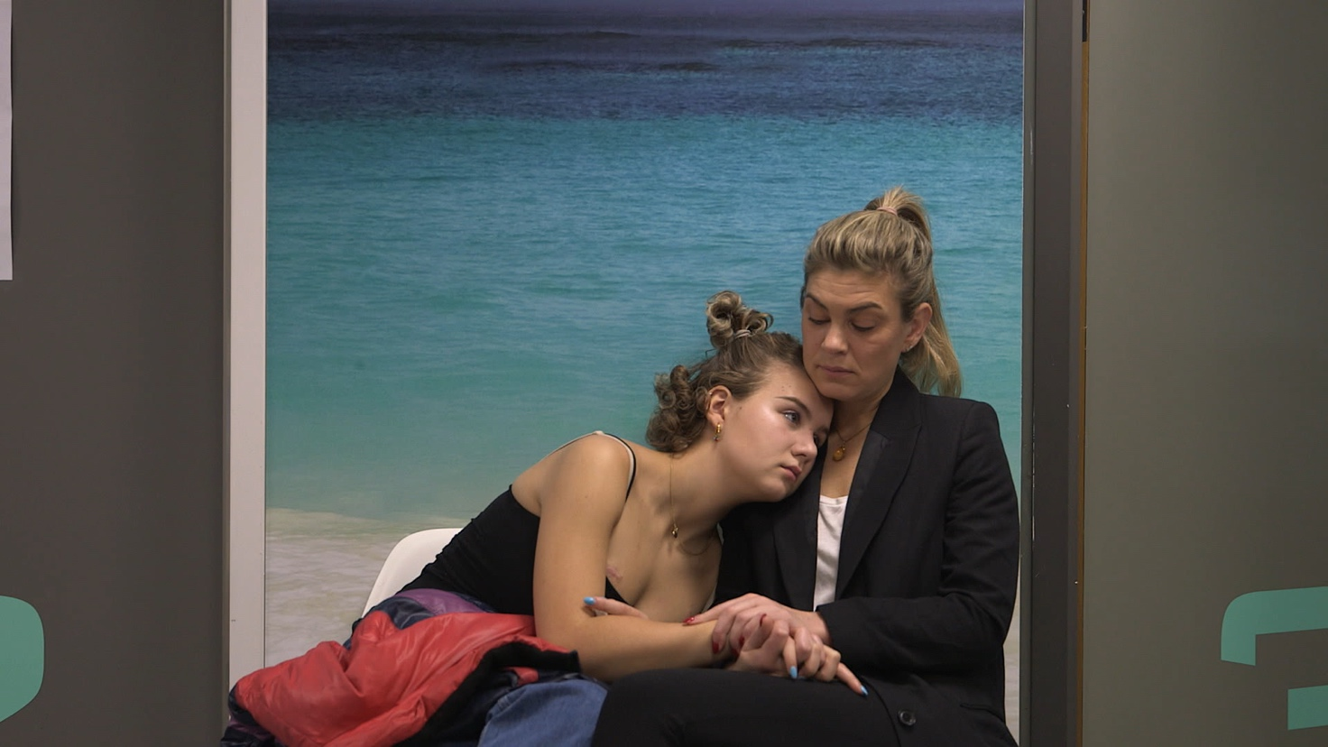
Photo: Sine Skibsholt

World premiere at CPH:DOX Friday March 20 at 7 pm in Grand Teatret, Copenhagen. Selected for the main competition DOX:AWARD.

The film has also been selected for CPH:MEETINGS which takes place Sunday March 22 at 2 pm at Aveny T.
The press is welcome to attend by appointment.

Links to the film are now available upon request. To set up interviews with Rosemarie or Sine Skibsholt, please contact publicist Line Bilenberg.

Press contact: Line Bilenberg, ph. (+ 45) 20710494, line.bilenberg@gmail.com
Press material can be downloaded at: www.madeincopenhagen.dk

CONTENT

Page 2 Introduction
Page 2 Synopsis
Page 3 Facts about Rosemarie and her illness
Page 3 Director’s thoughts and motivation by Sine Skibsholt
Page 4 Short biographies

INTRODUCTION
Rosemarie is a teenager with all that it entails. As wonderful as she can be, she is also quite a handful for her parents. Rosemarie is now declared healthy after having been critically ill from cancer twice in her life.

According to The Danish Cancer Society, the child’s natural separation process from their parents is often brought to a halt when he or she is diagnosed with cancer. Therefore, it can be particularly challenging to be diagnosed at that age. Teenagers often experience that they need their parents more than they did prior to becoming ill, both in terms of nurture and extended care, and thus the process of cutting ties is usually interrupted for a shorter or longer period of time.

Cancer is rare in children, but it’s the second most frequent cause of death after age one (accidents being the most frequent). Each year approx. 170 children are diagnosed with cancer in Denmark.

Cancer is something that affects the entire family and Sine Skibsholt’s new film Long, Live, Love shows how hard it can be for a parent to let go once their child is in the clear and finally healthy again. Rosemarie feels that she has missed out on so much and just wants to put the entire experience behind her. But that’s not easy if her mother isn’t able to do the same.

Long, Live, Love is a coming-of-age film with a twist. It’s a story about cancer - one that ends well. But it’s also a story about how hard it is for Rosemarie to move on with her life, when her mother is still in the throes of fear after having almost lost her, twice.

In Sine Skibsholt’s own words (see page 3): ”It quickly became clear to me that Rosemarie’s close relationship with her mother would be a central theme. Like so many other teenagers, Rosemarie hates and loves her mother in a mix of emotions that often lead to conflicts and arguments. But at the same time, there was a sense of intimacy and honesty between them that I think few teenagers and their parents manage to maintain.

In the relation between Rosemarie and her mother, it was easy to recognise the universal mother-daughter dynamic: Who am I in relation to you? But added to that, there was also another dimension at play: Who are we in this crisis? Who are we after? How does each of us move on? And how do we move on together?”

SYNOPSIS
Long, Live, Love is a coming-of-age story about Rosemarie - a teenager whose life has repeatedly introduced a seriousness, for which she is far too young. After beating cancer, twice, Rosemarie is now eager to get back to a typical teenage life of partying, drinking and kissing boys. But in the aftermath of her daughter’s illness, Rosemarie’s mother is paralyzed by fear of losing her and thus a constant reminder to Rosemarie that she was ill.
The film unfolds an intense mother-daughter drama, which Rosemarie must go through in order to understand and reconnect with her mother, while also trying to find herself in the midst of the chaos of life.

FACTS ABOUT ROSEMARIE AND HER ILLNESS
Rosemarie (16) lives with her mother, Katrine, her father, Anders, and her younger brother, Salomon (13) in Vesterbro, Copenhagen, a neighbourhood she was born and raised in. Her father is a restaurateur and he owns Fiskebaren in Kødbyen, amongst others. Her mother is the manager of a café and Rosemarie is now in grade 10 at a boarding school.

In 2007, when Rosemarie was 3 ½ years old, she was diagnosed with cancer, more specifically Wilms Tumor stage 5. Wilms Tumor is a type of kidney cancer that occurs most often in young children, and stage 5 means the cancer has spread to other parts of the body. Rosemarie had tumours in both of her kidneys, the lymphatic system and the lungs.
She was admitted to the children’s cancer ward at Rigshospitalet and step one was to take out an ovary with regards to fertility possibilities later in life, as well as stem cells for a potential transplant later on. And then she started chemotherapy with subsequent surgeries: The doctors had to remove one kidney and half of one of her lungs. After 1 ½ years, Rosemarie was declared healthy.
10 years later, in March 2017, the cancer returned in the form of a large mass, which hadn’t spread, and was located in the exact spot of the kidney before they took it out.

Wilms Tumor is a form of cancer that primarily develops in young children and therefore shouldn’t, and normally doesn’t, occur in children Rosemarie’s age (13). The doctors, however, do not know whether it was a relapse or if there was a small part in a lymph node, which wasn’t removed during the initial treatment back when Rosemarie was a child. They lean towards the latter.

In April 2017, Rosemarie was re-admitted to the children’s cancer ward at Rigshospitalet. She began an intensive chemotherapy treatment that knocked her entire system to the ground, and the mass was removed. The doctors took 10 lymph node samples in connection with the operation, and there was no trace of cancer in any of them. But to be absolutely certain, Rosemarie was put through the mill: 4 rounds of chemo before surgery. Surgery primo July, then stem cell transplantation including 3 weeks in isolation. And then radiation for six months.

She was discharged early September and went back to school the following day, even though the doctors advised against it. Rosemarie was declared healthy on May 30 2018, but has to come in for check-ups every six months for the next five years.

DIRECTOR’S THOUGHTS AND MOTIVATION
By Sine Skibsholt

”I’m preoccupied with the shift that happens inside of us when we experience for the first time just how fleeting life really is. I lost my cousin to cancer when we were quite young. She was like a sister to me, and that loss has influenced all aspects of who I am today.

I believe that it’s in this first encounter with death that we take one of the heaviest adult steps possible, one that brings us face to face with the brutal truth of life. The earlier that happens, the deeper the imprint.

The first time I filmed Rosemarie she was only 4 years old and had cancer. But already then I recognised in her an unspoken knowledge about the seriousness of life, not in an intellectual linguistic sense, but as something she had felt on her own body.

When I again aimed my camera at Rosemarie, some 10 years later, the cancer had come back and she was very ill. But she was also a typical Vesterbro-teenager – rebellious and freedom seeking –smack in the middle of the chaotic teenage years, where each day flourishes as an undiscovered opportunity, a new romance, a new story, always featuring Rosemarie as the main character. This dualism made her an interesting and complex character, who I felt like getting to know – again.

It quickly became clear to me that Rosemarie’s close relationship with her mother would be a central theme. Like so many other teenagers, Rosemarie hates and loves her mother in a mix of emotions that often lead to conflicts and arguments. But at the same time, there was a sense of intimacy and honesty between them that I think few teenagers and their parents manage to maintain.

In the relation between Rosemarie and her mother, it was easy to recognise the universal mother-daughter dynamic: Who am I in relation to you? But added to that, there was also another dimension at play: Who are we in this crisis? Who are we after? How does each of us move on? And how do we move on together?

As a storyteller, I’m interested in the time that follows ”the crisis” - the time when things are supposed to go back to normal. I find it an often overlooked part of the many stories about the crisis - but isn’t it when we are up against the wall, searching for ways to manage, overcome, fall and get back up again, isn’t this what shapes us, teaches us, and makes us who we are?

With this film, I wanted to look at youth as a challenging time that informs who we become. It’s a story about how fleeting life is – how brutal and how beautiful. A story about love, family and the complex dynamics inherent to living full on, while simultaneously accepting that at any given time it can all come to an end.”

SHORT BIOGRAPHIES

Director Sine Skibsholt b. 1979
Sine Skibsholt graduated from the National Film School of Denmark in 2011 as a documentary film director with the film Aside the Sea.

In 2016 Skibsholt had her documentary feature debut with the film Who We Were, which won a number of awards including Best First Appearance at the international documentary film festival IDFA, a Robert for Best Documentary Film, TV-prisen, Billedbladets TV-prize, as well as an honorary prize from the Danish Arts Foundation.

As a storyteller, Sine Skibsholt has a broad range of experience across many different areas including TV, radio and scriptwriter. For a number of years, Skibsholt worked at DR as a TV planner, production manager and host on varies documentary programmes as well as live TV and radio in the B&U youth department.

Productions include the documentary series for children, “Ramasjang Generationen” (2012 – 2015), and the documentary film, also for children, called “Albert flytter til USA” (2016).

Producer Helle Faber b. 1966
Graduated from the Danish School of Media and Journalism in 1991 and has since 2003 worked as a documentary film producer. She has produced a large number of award-winning documentary films for both the national and international market i.e. A Married Couple (2019), The Stranger (2017), Lost Warrior, (2017), Who We Were (2016), The Wait (2016), Motley’s Law (2015) and Warriors from the North (2014).
Helle Faber is CEO of the production company made in copenhagen, which she founded in 2010.

